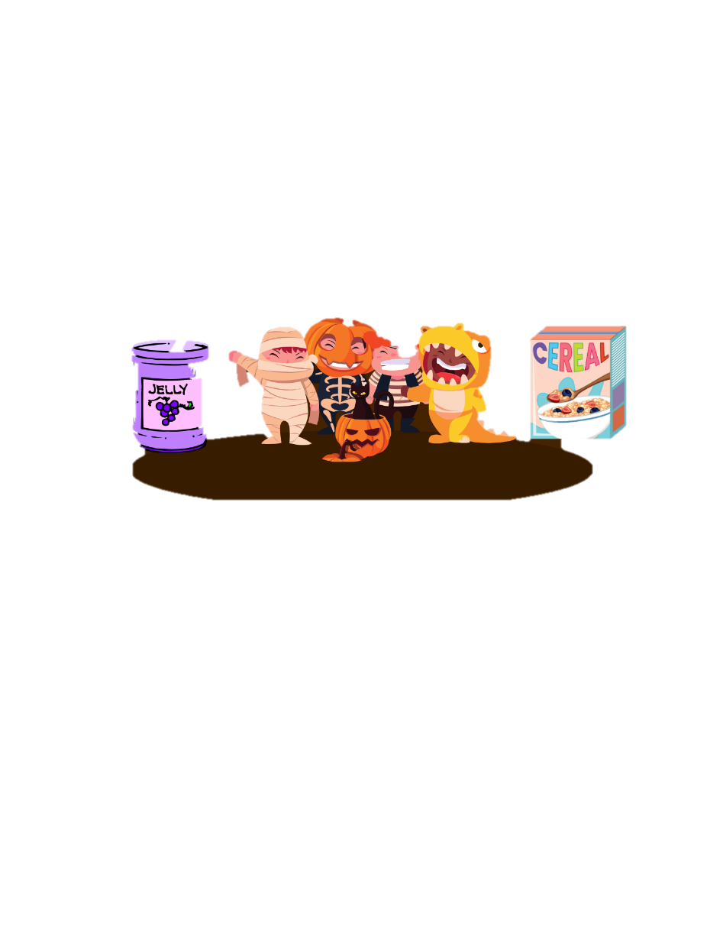
Character Parade Guidelines &
Community Service Project
Thursday, October 31st

KES has a long tradition of having a character parade each October. This year, our character parade will be on Thursday, October 31 at approximately 9:15 a.m. in the bus loop. Our parents and students have always enjoyed this event very much. We would like to continue the tradition of having our students participate in a community service project. This year we are proud to join with Homes 4 Heroes, a local organization for Veterans. Please choose an item from the donation list on the back of this flyer. Items can be dropped off on the day of the Parade or in the collection bins located in the breezeway through November 6.

To ensure that your child can fully participate and enjoy this event, please follow the costume guidelines. Costumes should be age-appropriate and fit appropriately to ensure your child’s safety when walking around. It is very difficult and takes away valuable time when we have to remove costume items or not allow a student to participate who does not follow the guidelines.

*Students should wear sneakers (no heels or boots) with their costumes.
*Students should come to school wearing their costumes and bring their school clothes in a bag to
change.
*It is very helpful for students to wear as much of their school clothes under their costume for ease
and to save time.
*No makeup (including fake blood) or spray color in hair
*No “scary” costumes or masks – Ex: Hockey or “Scream” masks
*No weapon props

Parents, if you would like to attend the Character Parade, you MUST have an approved School Access form on file. On the day of the Parade, please head to the bus loop to sign in and stay in the bus loop through the parade. Please do not go to the classroom. Additionally, we ask that parents stand on the INSIDE of the loop to have a good view without interfering with the students watching the parade. For safety reasons, please leave your pets at home. Thank you!
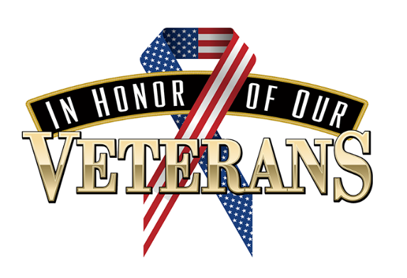
Ketterlinus Families and Friends -

Our school's Early Act Club is organizing a collection for our local veterans. Here is a news article about this local organization that provides affordable housing for veterans.

https://www.staugustine.com/story/lifestyle/2024/05/20/veterans-village-will-offer-affordable-housing-to-veterans/73775389007/

It is important to note that these apartments only have microwaves and small refrigerators. Food items need to be microwavable and non-perishable. New King-size sheets and blankets are welcome as well.

*jerky
*trail mix
*crackers
*canned tuna
*canned soup/ramen noodles
*microwavable popcorn
*canned fruit or fruit cups
*peanut butter and jelly (plastic jars, please!)
*cereal
*cookies
*shaving cream
*tooth paste
*mouth wash
*tooth brushes
*deodorant (men’s)
*Body wash/soap (men’s)
*new socks
*new king size sheets
*new blankets

