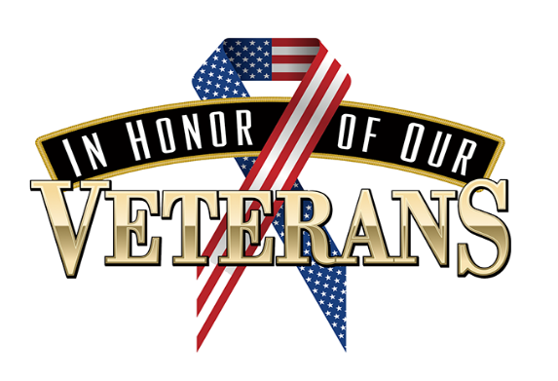

Ketterlinus Families and Friends -

Our school's Early Act Club is organizing a collection for our local veterans. Here is a news article about this local organization that provides affordable housing for veterans.

<https://www.staugustine.com/story/lifestyle/2024/05/20/veterans-village-will-offer-affordable-housing-to-veterans/73775389007/>

It is important to note that these apartments only have microwaves and small refrigerators. So, food items need to be microwavable and non-perishable. New KING size sheets and blankets are welcome as well.

Suggested items but any non-perishable food items are welcome:

\*jerky

\*trail mix

\*crackers

\*canned tuna

\*canned soup/ramen noodles

\*microwavable popcorn

\*canned fruit or fruit cups

\*peanut butter and jelly (plastic jars, please!)

\*cereal

\*cookies

\*shaving cream

\*tooth paste

\*mouth wash

\*tooth brushes

\*deodorant (men’s)

\*Body wash/soap (men’s)

\*new socks

\*new king size sheets

\*new blankets