FOOD DRIVE
November 14th-18th
Non-Perishable Foods (cans, jars, or boxes)
*No Glass Please *
Check Expiration Dates
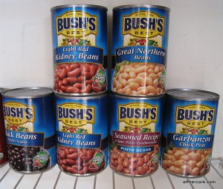
Pre-K and Kindergarten = Vegetables
1st Grade = Fruits and Desserts

2nd Grade = Boxed Potatoes
3rd Grade = Soups

4th Grade = Pasta, Canned Tomatoes/Sauce, Stuffing
5th Grade = Drinks - Coffee, Tea, Juice Boxes

Sponsored by Early Act

