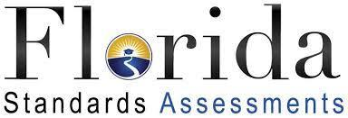

FSA testing dates for May 2021:

3rd grade Math: Session 1, May 10th and Session 2, May 11th

4th grade Reading: Session 1, May 3rd and Session 2, May 4th
4th grade Math: Session 1, May 12th and Session 2, May 13th

5th grade Reading: Session 1, May 6th and Session 2, May 7th
5th grade Math: Session 1, May 10th and Session 2, May 11th
5th grade Science: Session 1, May 17th and Session 2, May 18th

Proctoring Dates for May – 8:30-10:00 a.m.

May 3
May 4 – full
May 6 – full
May 7
May 10
May 11 – full
May 12
May 13 – full
May 17
May 18

