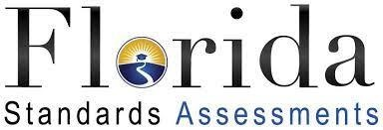

FSA Testing Dates for May 2021:

3rd grade Math: Session 1, May 10th and Session 2, May 11th
4th grade Reading: Session 1, May 3rd and Session 2, May 4th
4th grade Math: Session 1, May 12th and Session 2, May 13th
5th grade Reading: Session 1, May 6th and Session 2, May 7th
5th grade Math: Session 1, May 10th and Session 2, May 11th
5th grade Science: Session 1, May 17th and Session 2, May 18th

