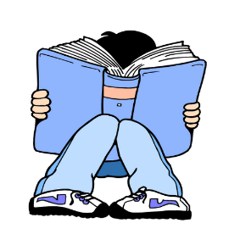
Literacy Week Daily Events 1/25-1/28
We encourage ALL students & staff to participate, have fun, and remember “Humanity Tells a Story: What’s Your Chapter?”
Monday- “Hats Off” to Literacy, inspired by Jon Klanson’s We Found A Hat-
Wear a hat to school & read!
Tuesday- “T-shirt Tuesday”, inspired by Peter Reynolds’ The Word Collector-
Wear Your Words t-shirt & read!
Wednesday- “Show Your Wacky Style”, inspired by Mark Sperring’s We’re All Works Of Art-
Wacky hair or mismatched clothes or your own personal style & read!
Thursday- “Reading Rocks, Wear Funky Socks or Masks!”, inspired by Jon Muth’s Zen Socks-
Wear crazy socks & read!

