Dolphin Digest
Volume 99, No. 1, October 2021

Ketterlinus Elementary School
Where we learn, love, and laugh.
67 Orange Street, St. Augustine, FL 32084
(904) 547-8540

Important Dates at Ketterlinus

10/1 Spirit Day - Wear your KES T-shirt
10/5 PTO Meeting - 8:00 a.m.
10/6 Early Release - 1:45 p.m.
10/6 Wear Your Words
10/8 Spirit Day - Wear your KES T-shirt
10/13 Early Release - 1:45 p.m.
10/15 Spirit Day - Wear your KES T-shirt
10/18-10/22 Bully Prevention/CC/Red Ribbon Week
10/18 Teacher Planning Day - Student Holiday
10/19 SAC Meeting - 7:50 a.m.
10/20 Early Release - 1:45 p.m.
10/22 Spirit Day - Wear your KES T-shirt
10/26 Report Cards Issued
10/27 Early Release - 1:45 p.m.

Principal’s Corner
Dear KES Families and Friends –
Welcome back! It is great to see returning students and families as well as meet our new ones. KES is such a special school. We are very fortunate to live in a great community. We all had high hopes over the summer that this year would be much different than last year. So, it is a bit of disappointment that we are still facing so many pandemic challenges. Thank you so much for all your support and kind words to me and our staff. I really cannot tell you enough how much it means to us. Despite the challenges we are all facing, our kids are FANTASTIC! I really do mean this. This is one of the best study bodies I have had in my 26 years of teaching. I give credit to you and our community. We appreciate that you support the school and reinforce good character. Our little school has become my oasis. Speaking for the staff, we find great joy and reward in seeing them so happy and eager to be here.
With much gratitude,
Kathy Tucker, Principal

At Ketterlinus our Dolphins S.W.I.M. so well! Keep up the great work!
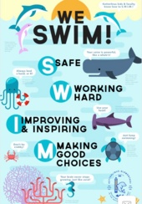

S = Safe
W = Working Hard
I = Improving & Inspiring
M = Making Good Choices

KES Cafeteria
Breakfast and lunch will be free to all students as part of the Cares Act/Federal waiver for the 21/22 school year. No application or other documentation is required for eligibility. Treats, such as ice cream and snacks, are an additional charge. You may pay cash, check, or pay virtually through paypams.com. For the October menu go to https://schools.mealviewer.com/school/KetterlinusElementary
John D. Harpst
Café Manager

Spirit Day at KES is every Friday! Students and staff are encouraged to show their spirit by wearing KES apparel or KES colors.

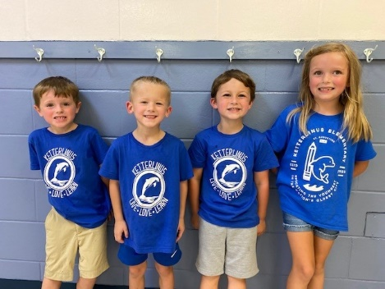

Housekeeping

Check-out Policy
Gentle reminder that we do not permit early checkout within 30 minutes of dismissal due to school-wide prep.
Dismissal Changes
Parents/guardians, please be sure to note dismissal changes in your student’s planner. This helps us to ensure a safe dismissal and avoid classroom interruption. In the event of an emergency dismissal change, you may call the office by 2:15 p.m. to provide our staff with the pertinent information.
Car Tags
Car tags must be displayed on your rearview mirror when picking up your child in Parent Pick-Up. This helps the staff to identify you as someone who is allowed to pick up your student, and gives staff the opportunity to radio ahead so that your child is ready at the curb for pick-up.
School Access
If you have not already done so, please complete a School Access form. This provides safety and security to our students and staff. In addition, any person passing beyond the front office area must show a valid driver’s license or state identification card. To apply for School Access, go to https://stjohns.keepntrack.com/apply/ . Please note this process can take up to 4-6 weeks.
Covid-19 Information
We know you may have many questions about Covid, and we totally understand! The district has a great website full of information such as, Health and Wellness Resources, Instructional Documents, Health & Safety Documents and much more. Please go to https://www.stjohns.k12.fl.us/covid-19/.

WordMasters Challenge

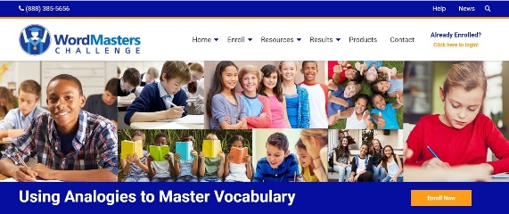
This year our Grade 3-5 students will be competing again in the WordMasters Challenge. Last year we had 2 students rank in the top performers nationally! The WordMasters Challenge™ is a national competition for students in grades 3-8 that encourages growth in vocabulary and verbal reasoning. Each year, over 125,000 students from some of the best public and private schools throughout the United States participate in the WordMasters Challenge. The WordMasters Challenge™ helps students learn to think both analytically and metaphorically. The contest addresses higher-level word comprehension and verbal reasoning. Excellence in the competition will require both a mastery of the meanings of the vocabulary words (of a difficulty appropriate to each grade level) and thoughtful reasoning about the relationships between these words and more familiar language used in the competition’s analogies. Our students will begin their training October 1, and their first meet will be November 17.

“Art We Awesome”

On WOW Wednesdays, Kindergarten through fifth grade students are participating in the Meet the Masters program. Meet the Masters teaches art history of master artists in three stages: Introducing the Master, Learning from the Master, and Working with the Master. Our current artist is Frida Kahlo. During our introduction and PowerPoint presentation, we discussed the life and struggles of our artist and how she worked through them. In the learning stage, we learned to look closely with our eyes and study the lines and shapes of objects to copy or redraw them. In our final stage, Working with Kahlo, we will create a masterpiece in the style of our artist.

Student Advisory Council (SAC) Dates for 2021/2022
What is SAC? It is a group of parents, staff, and community members who meet monthly to discuss Ketterlinus’s school goals and make decisions that are in the best interest of the school.
Our KES SAC meetings are held on the 3rd Tuesdays of the month at 7:50 a.m. at a location TBA. We are looking for members and would love for you to be a part of this team. To sign up, or if you would like more information, please contact Bethany Hilbert at Bethany.Hilbert@stjohns.k12.fl.us.

September 21
October 19
November 16
December 14
January 18
February 15
March 22
April 19
May 17

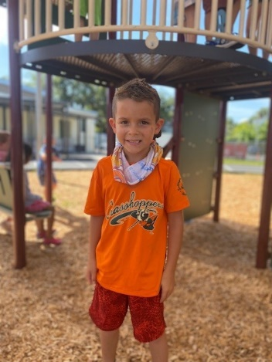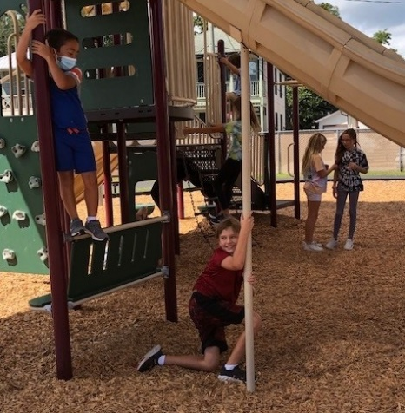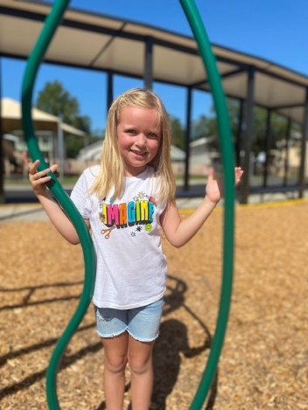

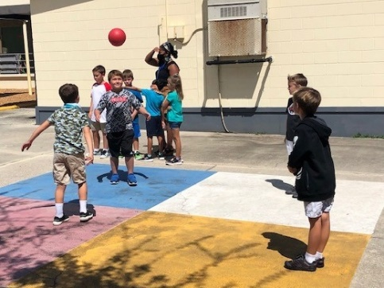

Recess is one of our favorite activities here at KES! We love for the students to get some sunshine and fresh air!

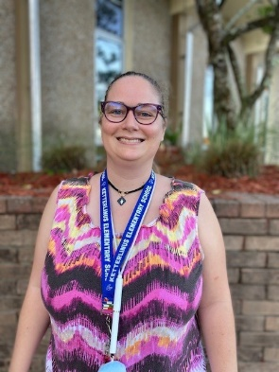
Music News
Join us in welcoming our new music teacher, Angelia Delesdernier, (or better known as Mrs. D.). Mrs. D. graduated from Rollins College with a Music Degree. She worked part time for 5 years at a private school in Ormond Beach and as a substitute teacher in Flagler County. In her free time, Mrs. D. loves to play board games, cards, and computer games, and collect strange and unique instruments.

Cove Corner
Greeting KES families! We have so many exciting things planned for the Cove! Our annual staff Pumpkin Patch Project is right around the corner, as are Fun Fridays. Our October special is “It’s Time to Harvest,” and will be on 10/29 from 3:00-5:00 p.m. The afternoon will be filled with activities such as pie-eating contests, face painting, cool arts and crafts, games, and much more! If you are interested in enrolling your student in The Cove, please contact Janet Bryant at Janet.Bryant@stjohns.k12.fl.us or at 547-8540 ext.18971

Coach’s Corner
First Quarter is quickly coming to an end. P.E. is going well.
Just a few reminders for P.E.
- Students need to wear tennis shoes (sneakers) for P.E. (No boots, street shoes, crocs, turf cleats, etc.) Shoes other than sneakers can be unsafe on the gym floor.
- Long hair needs to be pulled back off the face (boys and girls). Students need to be able to see where they are going and their surroundings.
- Bring a water bottle filled with WATER only... no flavored water or drinks of any kind.

WISHLIST: Hair bands, hair ties, and hair clips would be greatly appreciated!!
Thank you,
Coach Allen

STEAM LAB

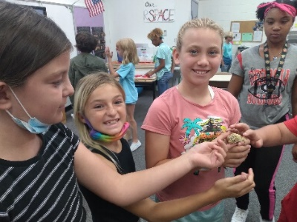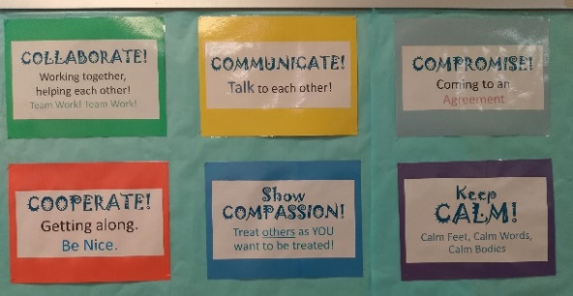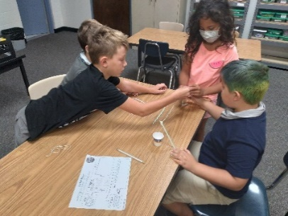

All KES students had the opportunity to meet the class pet in the STEAM Lab this month! Meet Stripes, our leopard gecko. The students are also starting to do engineering challenges, which are permissible by following S.W.I.M and Mrs. Tierney’s 6 C’s: Collaborate, Communicate, Compromise, Cooperate, Compassion, Calm. Ask your child to model these behaviors for you.
Mrs. Tierney

PTO News

Here’s to a bright school year! The PTO started off the year with a Back-to-School Cookout and goodie bags for our KES staff. Thank you, KES families, for your donations and for volunteering to make this happen. We appreciate our staff and volunteers!

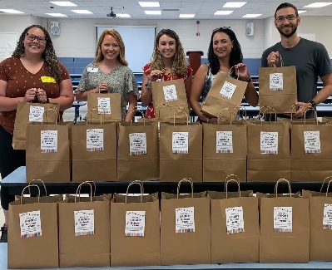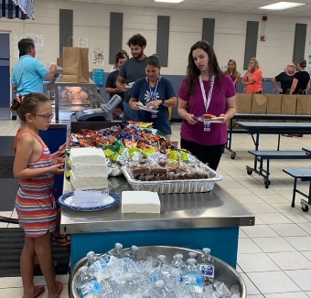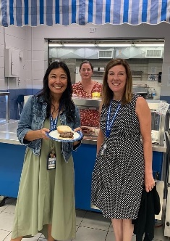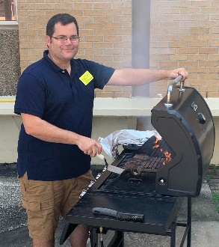

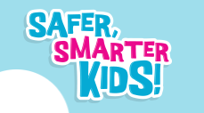
In the coming weeks, all students Kindergarten – 5th grade will be introduced to the Safer, Smarter Kids curriculum. Safer, Smarter Kids is an abuse prevention education curriculum designed for Pre-K and elementary-aged children, created by the Lauren’s Kids foundation. Lauren’s Kids is an organization founded and led by Lauren Book, M.S. Ed. This district approved curriculum introduces students to personal safety, understanding safe and unsafe situations, and teaching them Safety Tools to use in any situation when they may feel unsafe. This curriculum meets the new state mandate to teach Child Trafficking prevention. For more information, please visit www.safersmarterkids.org and the Florida Department of Education.

From the Guidance Counselor
Welcome back!! It has been wonderful seeing all the students settle into their classes and begin another year. My name is Sandy McCutcheon and as the School Counselor, I have the awesome job of getting to know ALL students. I am here to offer support to students so they can be successful academically, socially, and behaviorally. During the first week of school, I visited all VPK–5th grade classrooms and talked about Character Counts! and starting off the school year with traits that make a successful student. My goal is to meet with classes monthly and provide lessons that build on students’ social emotional learning. I am also available to work with students through small group sessions, individual sessions and with teachers and parents by providing resources and education regarding issues that affect students. Please feel free to call me at (904) 547-8545 or email me at sandy.mccutcheon@stjohns.k12.fl.us.

October is a busy month with all things character. The week of October 18, KES will celebrate Kindness Week, which focuses on Red Ribbon Day/Drug prevention/Character Counts!/Bully Prevention. Students will receive additional information in the coming weeks.

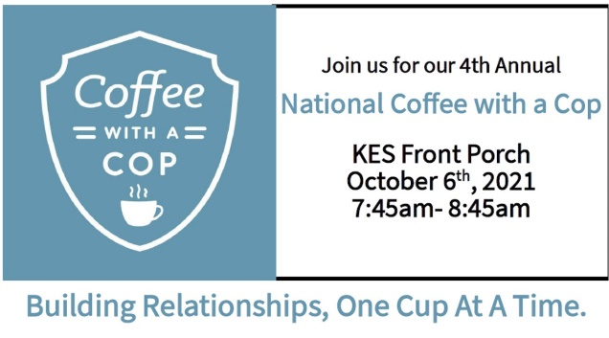

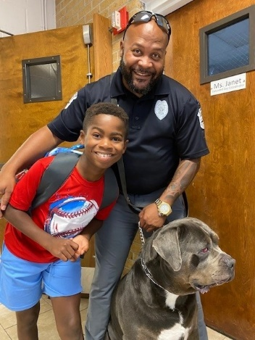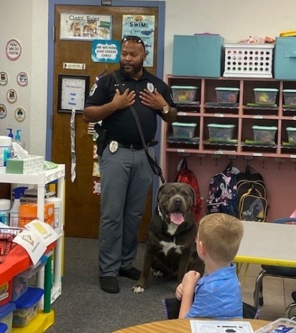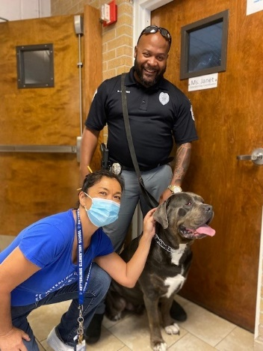

Diesel and Officer Brown came back for a visit! Diesel is an all-time sloppy favorite here at KES, weighing in at 135 lbs.! Funny thing is, he always turns his head when a camera is on him. But check out the middle picture…we got a snapshot of him!

Ketterlinus Elementary School encourages persons with disabilities to participate in all the programs and activities scheduled at KES. If you anticipate needing any type of accommodation or have questions about the physical access provided, please call the front office 24 hours prior to participation or visit.

