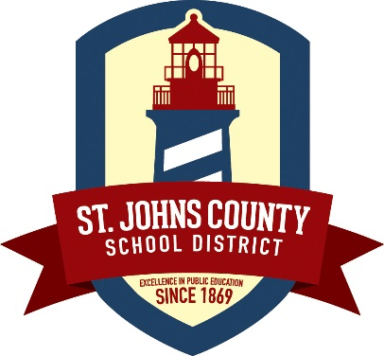
Media Release
40 Orange Street
St. Augustine, FL 32084
Joseph Joyner, Ed.D. Superintendent
Christina Langston, Chief of Community Relations
Phone 904-547-7504 · Fax 904-547-7523
www.stjohns.k12.fl.us

May 19, 2015

The St. Johns County School District’s (SJCSD) bus routes for the 2015-2016 school year were approved by the School Board at their May 12 meeting.

The routes are available online at www.stjohns.k12.fl.us/transportation/routes. Parents without access to computers may visit any of the county public library locations, and staff will assist them in locating the website.

“By providing this information prior to the end of school, parents and caregivers are better able to plan and prepare,” said SJCSD Director of Transportation Joe Purvis.

In mid-July, postcards will be sent home to the parents of all potential bus riders giving them the bus stop, times and bus number for their students.

The Transportation Department will operate 175 bus routes and transport approximately 60 percent of the district’s students twice a day when school starts on Monday, August 10. For additional questions or information, call the Transportation Department at 547-7810.

# # #

