Please Join Us for the Planning Meeting of a new Parent Support Group!!
October 22,2013 at 6:30PM
This is your chance to help form a support group, so bring your ideas, thoughts, hopes and concerns and Let’s Talk!
We will provide some snacks/ refreshments.
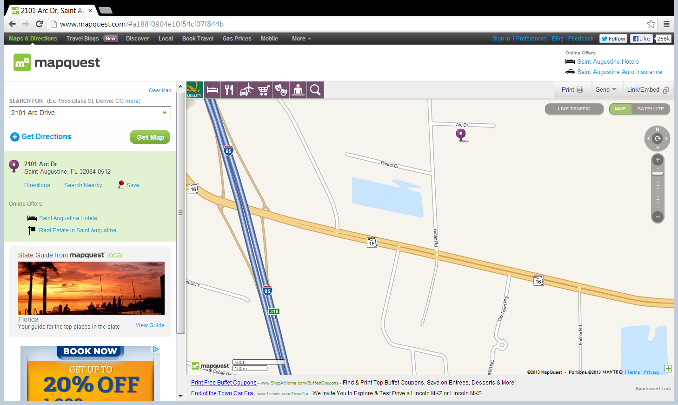

Childcare can be provided with R.S.V.P.
Susan Creek, coordinator 352 328-4724

